Author instructions for submitting content
- At first, use the submission link provided by your conference organizer.

- Enter all required information, upload the file and submit
- Return to your account details to view and approve the file to complete the submission
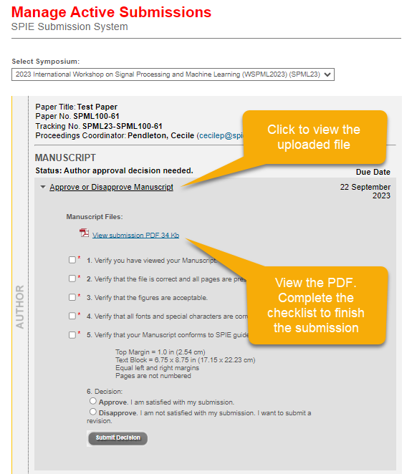
- Later, if you are returning to the submission system again, login to your account at SPIE.org by clicking on the person icon at the top right of the screen.

- Once you are logged in, click on the red circle icon with your initial to see a drop-down menu.
Click “Account details”.
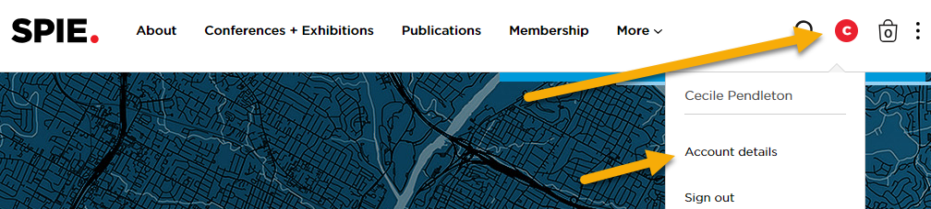
- Enter the Submission and Review System by clicking on the link for your symposium.
The symposium title in blue is a link.
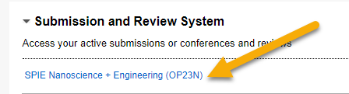
- Manage your active submissions using the links for your presentation

